**User Story Name: View Information on Website**

* Description: **As a** User **I would like** to have access to more information about the SkillCourt application **so that** I can learn more about what I can do with the app.

Acceptance Criteria

* User has access to information about multiple aspects of the SkillCourt mobile application

**Use Case**

* Name: View Information on Website
* Actor: User
* Preconditions: User is on the ‘Explore’ page
* Description: User will be able to cycle through multiple pages of information regarding the SkillCo

<Flow of events>:

|  |  |
| --- | --- |
| Actor Steps | System Steps |
| 1. User clicks on ‘next’ arrow in the ‘SkillCourt App’ section |  |
|  | 1. Next page of application information is displayed to the user |
| 1. User clicks on ‘previous’ arrow in the ‘SkillCourt App’ section |  |
|  | 1. Previous page of application information is displayed to the user |

**Use Case Diagram**

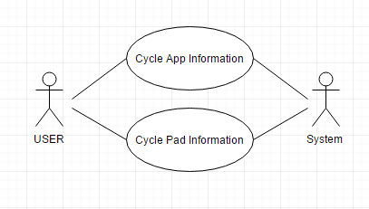

**Sequence Diagram**

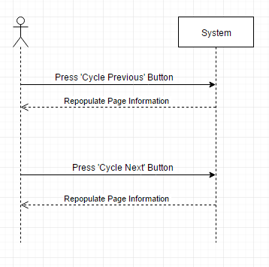

**Class Diagram**

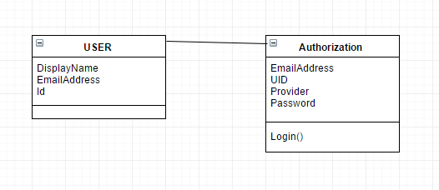

**Unit Test**

* Test case ID: Add Information to Website
* Description/Summary of Test: Make sure that the cycling of application information works properly
* Pre-condition: User has navigated to the ‘Explore’ page
* Expected Results: Cycling works properly 100 times (50 previous, 50 next)
* Actual Result: Cycling worked properly each time one of the arrows was clicked
* Status (Fail/Pass): Pass

**Integration Test**

**Visual User Guide** <like one or two screenshots of the feature. For the hardware project, a photo of device is required>